2026 LAKESMART HOMEOWNER QUESTIONNAIRE
Thank you for requesting a LakeSmart evaluation on your property! We are excited about visiting your property to discuss steps you can take to protect your lake and to recognize what you have already done. Please complete this form and return it to your evaluator prior to their visit. |  |  |  |  |  |  |  |  |  |  |  |  |  |  |  |  |  |  |  | 
You will receive a written report summarizing your LakeSmart evaluation with specific recommendations for your property. You don’t need to be present during the site visit. Please share your preference:
 | ☐ YES, I would like to be present during the site visit
 | ☐ NO, I will not be present during the site visit
Evaluator Name and Phone/Email: |  |  |  |  |  |  |  | Click or tap here to enter text.
HOMEOWNER CONTACT INFORMATION
Primary Homeowner Name: |  |  |  |  |  | Click or tap here to enter text.
Site Address: |  |  | Click or tap here to enter text.
Phone Number: |  |  |  | Click or tap here to enter text. |  |  |  |  |  |  | Email Address: |  |  |  |  |  | Click or tap here to enter text.
Winter Address: |  |  |  | Click or tap here to enter text.
PROPERTY DETAILS
 | Has this property been previously evaluated? |  |  |  |  |  |  |  |  |  |  |  |  | ☐ YES |  |  |  | ☐ NO
 | What year was the home built? |  |  |  |  |  |  |  | Year |  |  |  | How long have you owned the home? |  |  |  |  |  |  |  | # Years
 | Do you live here year-round? |  |  |  |  |  | ☐ YES |  |  | ☐ NO
 | Do you belong to a camp, road, or other lake organization? (If so, please list):
 |  | Click or tap here to enter text.
 | What is the estimated shoreline frontage of the property? |  |  |  |  |  |  |  |  |  |  |  |  |  |  | # in Feet.
PROPERTY MAINTENANCE
 | How often do you use pesticides? (e.g., herbicides, insecticides, rodenticides, fungicides, etc.)
 | ☐ NEVER |  |  |  | ☐ RARELY (once or twice/year) |  |  |  |  |  |  |  |  |  | ☐ OFTEN (three or more times/year)
8. | How often do you use fertilizer?
 | ☐ NEVER |  |  |  | ☐ RARELY (once or twice/year) |  |  |  |  |  |  |  |  |  | ☐ OFTEN (three or more times/year)
9. | Do you mow grass? If so, where is your lawn mower blade set?
 | ☐ HIGH |  |  |  | ☐ MEDIUM |  |  |  |  | ☐ LOW |  |  |  |  |  |  |  |  | ☐ I DON’T MOW

SEPTIC SYSTEM INFORMATION
10. | Do you know where your septic tank and leach field are located? |  |  |  |  |  |  | ☐ YES |  |  | ☐ NO
 | If yes, please describe/sketch where they are below. If you do not know, visit lakes.me/septic for a link to a searchable database of septic permit applications, dating back to 1974.
 | Click or tap here to enter text.
11. | Do you know when your septic system was installed? |  |  |  | ☐ YES |  | Year installed: |  |  |  |  | Year |  |  | ☐ NO
12. | Do you know the size of your septic tank? | ☐ YES |  | Number of gallons: |  |  |  |  |  | # Gallons |  |  |  |  | ☐ NO
13. | Do you have a regular tank pumping schedule? |  | ☐ YES |  |  | Frequency: |  |  | # Years |  |  |  |  |  | ☐ NO
LOON SMART MERIT AWARD
14. | Will you take 5 actions (see next page) for the Loon Smart Merit Award? |  |  |  |  |  |  |  | ☐ YES |  |  |  |  | ☐ NO
15. | Will you share these actions with three neighbors? |  |  |  |  |  |  |  | ☐ YES |  |  |  |  | ☐ NO
PERMISSIONS
The LakeSmart program is a voluntary, educational, and non-regulatory program. Information collected through participation in the LakeSmart program will NEVER be used for regulatory purposes and will not be shared outside the LakeSmart database without the expressed permission of the homeowner.
16. | May we post your name/lake on our website for participating in the program? |  |  |  |  |  |  |  |  |  |  |  | ☐ YES |  | ☐ NO
17. | May we use photos for teaching/promotion (no names/addresses shared)? |  |  |  |  |  |  |  |  |  |  |  | ☐ YES |  | ☐ NO
18. | Would you like to subscribe (free!) to LakeSmart Living, a twice-yearly e-newsletter for shoreland homeowners interested in learning more about how to maintain and improve lakefront properties using lake-friendly practices? |  |  |  |  |  |  |  |  |  |  |  | ☐ YES |  | ☐ NO
Thank you for scheduling a LakeSmart visit and taking this step to protect your lake!
3/8/26
www.lakesmart.org

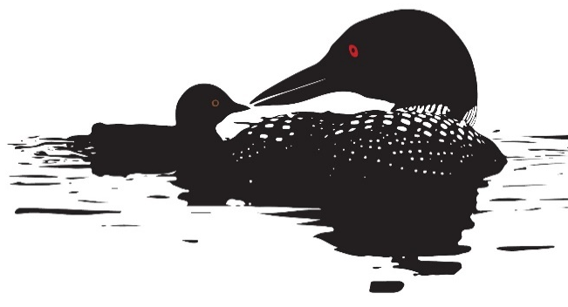
LOON SMART MERIT AWARD

Maine Lakes and Maine Audubon recognize homeowners with a Loon Smart Merit Award if their practices protect loons and their habitat. Standards for this award include how the property is used and the practices and commitments of the property owner.
LOON
- Loons are visual predators. Minimizing runoff and siltation to maintain water quality is critically important to their ability to fish and find food for their young.
- Loons are sensitive to disturbance on their lakeside nests and on the water. Being aware of where loons are and keeping a good distance away, especially in canoes and kayaks in wetlands and shallow water, will help minimize stress.
- Loons nest right next to the water where boat wakes can flood the nest and wash the eggs away. Keeping to headway speed as required in the 200-foot Boater Safety Zone will reduce this risk.
- Loons can pop up unintentionally in the path of oncoming boats. Boat strikes are thought to be one of the leading causes of adult loon mortality in Maine. Watching for loons while boating can help reduce this risk.
- Loon predators include skunks and raccoons that can make quick work of loon eggs. Reducing attractants to keep these predators away from nesting areas will help improve loon nesting success.
- The ingestion of lead tackle and the entanglement of loons in monofilament line (not biodegradable) are ever-present problems for loons in Maine. To help keep our loon population healthy for years to come, it is best to fish lead free, properly dispose of lead tackle, and recycle monofilament line.
LakeSmart Awardees who qualify for the Loon Smart Merit Award are given a Loon Smart sticker (pictured above) that can be displayed on their LakeSmart Award signs. To qualify for a Loon Smart Merit Award, a homeowner will need to take the following steps:
1. Agree to take the following 5 simple actions:
- Fish lead-free.
- Remove monofilament line from the lake and its shoreline.
- Stay at least 200 feet away from loons and loon nests when boating.
- Maintain a “no wake” speed within 200 feet of shore.
- Seal outdoor trash cans and feed pets indoors to deter predators.
2. Agree to share these actions with three neighbors.
3. Earn a LakeSmart Award and meet slightly higher Loon Smart standards for managing erosion and maintaining a robust shoreline buffer.

