
Bentley Memorial Library
Board of Assessment Appeals
Calendar
Other Information
Recreation
Senior and Social Services
Tax Collector
All Town offices and Bentley Memorial Library will be CLOSED on Monday, February 16, in observance of Presidents’ Day.
There will be no delay in trash and recycling pickup.

Business of the Month: MUNSON’S CHOCOLATES

The Town of Bolton is happy to announce that the Business of the Month for February is MUNSON’S CHOCOLATES. Munson’s Chocolates is a world-famous chocolatier that has been around for nearly 80 years. Everything you need for Valentine’s Day can be found at Munson’s whether it’s their famous Heart Shaped Boxes, Gourmet Truffles, a special chocolate novelty or maybe you want to pick out your own custom variety box of chocolates for that special someone.

Munson’s Chocolates is owned by the Munson family, a local family with deep roots in the area. Originally called the Dandy Candy Company, Josephine and Benjamin Munson opened their business in Manchester in 1946. After a brief period in Manchester, they decided to relocate their business to an old horse barn in Bolton. To this very day, their business is still located right where that old horse barn used to be.

So, on behalf of the town, we are proud to announce Munson’s Chocolate as the Business of the Month and encourage everyone to stop by.

For more information about Munson’s Chocolate click here.
NOTICE OF PUBLIC INFORMATION SESSION
REGARDING THE FIRST SELECTMAN’S SALARY
Tuesday, February 17, 2026, 6:00 p.m.
Bolton Town Hall - 222 Bolton Center Road, Bolton, CT
An information session will be held on Tuesday, February 17, 2026, at 6:00 p.m. at the Bolton Town Hall at 222 Bolton Center Road, Bolton, CT, regarding the First Selectman’s salary. Information is posted on the Town’s website, and copies will be available at the information session. The public will be permitted to comment and ask questions. In order to make the most of our available time, speakers will be limited to no more than 2 minutes each, and we ask that only new information be shared by each speaker, so information is not repeated.

If you would like to join this meeting via Zoom, please email skamara@boltonct.gov no later than 3:00 p.m. on Tuesday, February 17, 2026, to receive the Zoom information.


Thursday, February 19, 2026, from 5:00 to 6:15 p.m.
Bolton Town Hall - 222 Bolton Center Road, Bolton, CT
The Town of Bolton will host a Coffee and Conversation to discuss the budget and capital budget, and also to talk about the infrastructure for water lines and economic growth opportunities that may be connected to it.
If you would like to join the meeting via Zoom, please email hr@boltonct.gov no later than 3:00 p.m. on the day of the conversation to receive the login information.
Panelists Include: Rodney Fournier – First Selectman
Jim Rupert – Town Administrator
David Caruso – Superintendent of Schools
Ross Lally – Chair of the Finance Committee
Residents will be able to ask questions regarding the budget during the conversation. If you would like to submit questions beforehand, please send them to hr@boltonct.gov. The panelists will answer as many submitted questions as time permits.
PLEASE NOTE: The Public Information Session regarding the First Selectman’s Salary (skamara@boltonct.gov) and the Coffee and Conversation (hr@boltonct.gov) are two separate meetings, on different dates and different Zoom links. Please be aware of which meetings you are requesting Zoom information for.
FROM THE TAX COLLECTOR'S OFFICE
– PLEASE READ – Due to staff shortages, there will be limited services available in the tax collector’s office from February 24 to March 6. You may pay your tax bill online, drop it off in the drop slot by the tax collector’s door, or by mail. Please plan ahead if you need to register a car. Absolutely no immediate take off’s will be able to be made during that time period.

CLICK HERE FOR 2025 TAX PAYMENTS MADE

Once you put in your name, check the “IRS Payment Records for Year 2025.”
Check all accounts you want to include in your report and then click “VIEW IRS.”
You can then print that page out for your records.

LEGAL NOTICE
BOARD OF ASSESSMENT APPEALS
Property owners and lessees have the right under Connecticut General Statutes, Sections 12-110, 12-111 and 12-504d to appeal the assessment of motor vehicles, personal property and real estate on the 2025 Grand List. CGS §12-117 requires written appeals to be received by the Board of Assessment Appeals at Town Hall on or before 1:00 pm, Friday, February 20, 2026. Appellants will be notified of the time and date in March 2026 when the BAA will hear their appeal. The BAA is scheduled to meet in the Bolton Town Hall on March 10, 2026, with additional dates in March if needed.
The appeal form must contain the following information: the property owner’s name; name and position of the signer; description of the property that is the subject of the appeal; name and mailing address of the party to be sent all correspondence by the BAA, reason for the appeal, appellant’s estimate of value and dated signature of the property owner or duly authorized agent of the property owner.
If any of these items are not provided, the Board can decide not to hear an appeal.
Appeal forms are available on the Assessor's Office website.
BOARD OF ASSESSMENT APPEALS
Mary Terhune, Matthew Wraight, Amanda Gordon

SENIOR & SOCIAL SERVICES

Registration is required at least one week in advance for these programs.
Space is limited. Call 860-647-9196

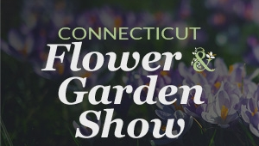
CT FLOWER & GARDEN SHOW
Think of spring and blooming flowers when we visit the CT Flower & Garden Show on Thursday, February 19. The van leaves the Senior Center at noon. Tickets are $20 payable in cash at the entrance to the show. Limit 20 participants.

---------------------------------------------------------------------------------------------------------------------------

WE STILL HAVE SEATS AVAILABLE!!
COLLEGE BASEBALL AT HARTFORD YARD GOATS FRIDAY, APRIL 24
Come see the University of Hartford play Western Connecticut State University. The senior van leaves the Bolton Senior Center at 9:15 a.m. The game starts at 10:30
Tickets are $17 (cash only) per person and include: your ticket, lunch with a hot dog, water, and chips. Concession stands will be open for additional food. The seats are covered, and there will be entertainment.



BENTLEY MEMORIAL LIBRARY


STORYTIME AT THE LIBRARY
Wednesday, February 18th
﻿**12:00-12:30** - NEW TIME

Storytime will continue on these select Wednesdays in February! Come and enjoy stories and a simple craft. Feel free to bring your own snack or lunch. The change in time was made to accommodate the nursery school schedule.
---------------------------------------------------------------------------------------------------------------------------

BOLTON PUBLIC SCHOOLS ART SHOW

Stop by Bentley Memorial Library to appreciate the incredible artwork created by students of Bolton High School and Bolton Center School.

The opening reception, sponsored by the Friends of Bentley Memorial Library, will take place on Tuesday, February 3rd from 6:00 t0 7:00 PM. The student work will be on display throughout the month of February.

----------------------------------------------------------------------------------------------------------------------
ELEANOR OLIPHANT IS COMPLETELY FINE
BY GAIL HONEYMAN
Wednesday, February 25th at noon

This story follows Eleanor as she learns to navigate the world and open herself up to friendship and love, with the help of a kind IT colleague and an elderly man they rescue. It's known for its blend of humor, warmth and emotional depth; exploring themes of loneliness, trauma, and healing. This book explores human connections and offers a 'warm hug' feeling - just the right blend for a good February read!

Preregister for Eleanor Oliphant is Completely Fine

RECREATION DEPARTMENT


KAREN'S CARDIO FITNESS WORKOUTS
Exercise for men and women!

When: Mondays, 5:30 pm - 6:30 pm
Where: Herrick Park, 29 Hebron Rd, Bolton, CT

Cost: $40.00 for 8 class punch card | $80.00 for 16 class punch card
$7 walk-in fee - Sign up with Karen Cordero: corderok53@gmail.com
Drop-ins are welcome :)
----------------------------------------------------------------------------------------------------------------------

JUJITSU WITH MASTER PATRICK CASSIDY
When: Monday and Wednesday, 7:00 pm
Where: Herrick Park, 29 Hebron Rd, Bolton, CT 06043,
November through April.

Learn self-defense techniques, build confidence, and take control of your personal protection against aggressive attackers through the art of jujitsu. Cost: $80.00/month paid to the instructor at class.

Questions or concerns, contact Master Patrick Cassidy (860) 539-0601
---------------------------------------------------------------------------------------------------------------------------

ALL LEVELS YOGA
When: Thursday nights, 6:00 -7:00 pm
Who: All Levels Yoga
Where: Herrick Park, 29 Hebron Rd
Cost: $15.00 drop-in fee paid to instructor
Register HERE

---------------------------------------------------------------------------------------------------------------------------
Drop in Adult Volleyball: DURING THE SCHOOL YEAR ONLY!
Registration is not required simply show up when you are available! :)
Monday nights at Bolton Center School @ 7:00 pm- 10:00 pm
Drop-in fee: $2.00 residents; $4.00 non-residents
Season passes: $30.00 for residents and $50 for non-residents.
Cash and Check are the only forms of payment available

OTHER EVENTS AND INFORMATION

BOLTON MOBILE FOODSHARE


The Bolton Mobile Foodshare will be held from 10:00 to 10:30 AM at St. George’s Episcopal Church, 1150 Boston Turnpike, Bolton, CT. This is an outdoor food distribution that assists families in need.

Upcoming dates: Tuesdays, February 24
Tuesdays, March 10 and 24
-------------------------------------------------------------------------------------------------------------------------------

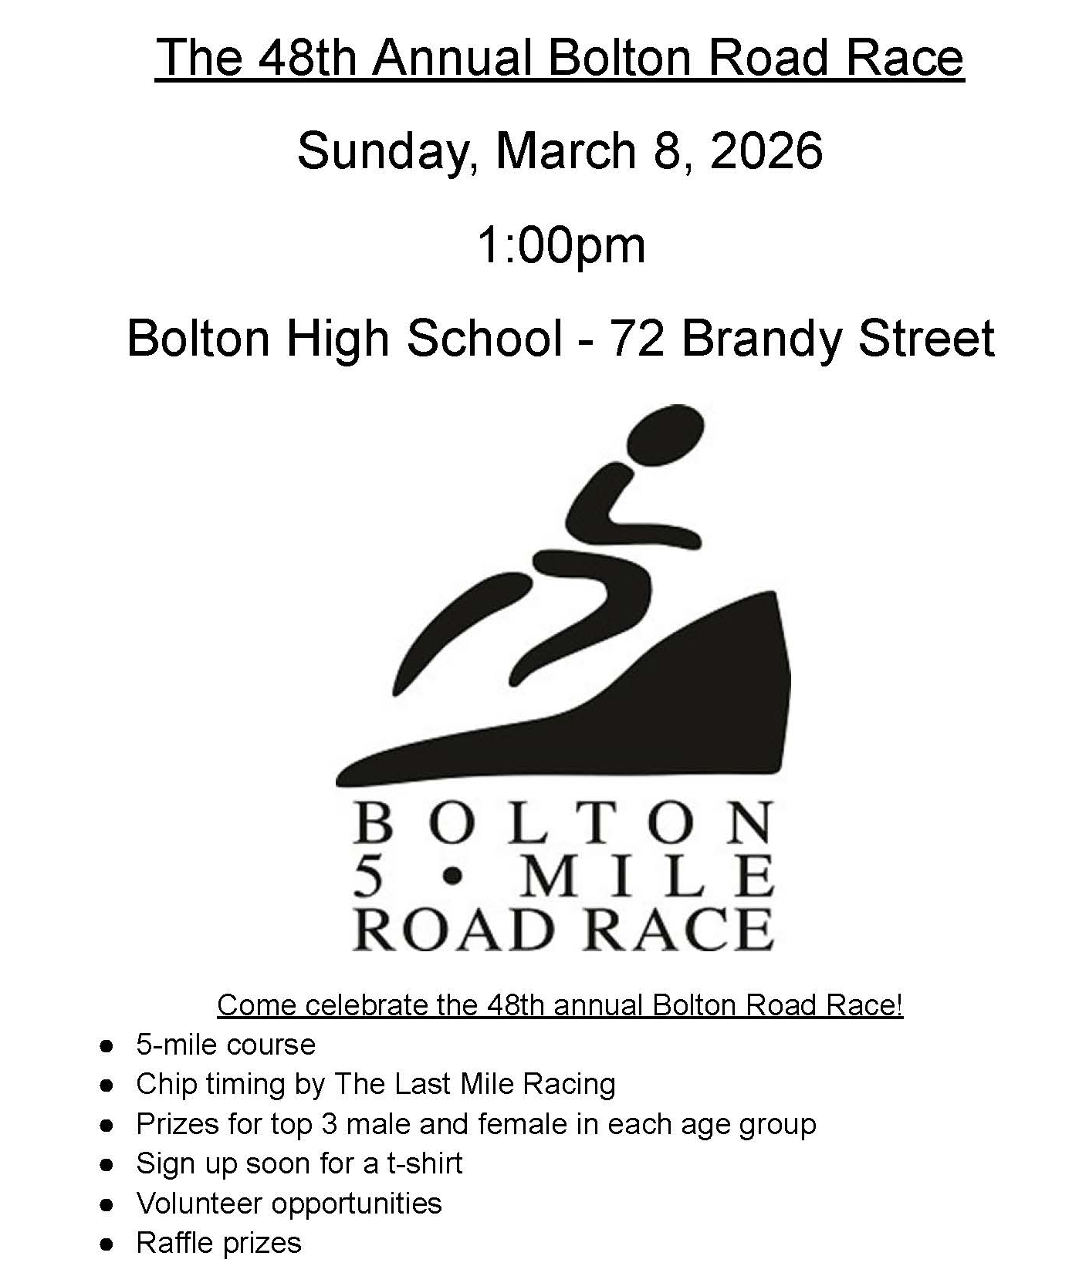
Register here.
Volunteer here.


BOLTON CENTER SCHOOL – 2026-2027 KINDERGARTEN REGISTRATION

Bolton Center School will hold Kindergarten Registration for the 2026-2027 school year in the Main Office starting Monday, February 23rd. Parents will need to contact the main office at 860-643-2411 and speak with Judy Ramsdell to schedule an appointment for registration. We encourage parents to access the registration forms online via our website (www.boltonpublicschools.com) and complete them prior to coming to the school office.

Children must be 5 years old on or before September 1, 2026 to be eligible. Please bring the following documents:

- Child’s Birth Certificate
- Proof of parents’ residency (see Bolton Residency Requirements on our website)
- Current immunization and physical information

Other important dates:
Please check back regarding final dates for the following informational meetings.

- May 5th will be the incoming kindergarten parent meeting from
6:00 p.m. – 7:00 p.m., via Zoom.
- May 28th will be the school visit/screening
- August 25th will be the teacher meet & greet and bus ride

The Bolton Center School is located at 108 Notch Road, Bolton, CT. Please contact the Main Office at 860-643-2411 if you have any questions.

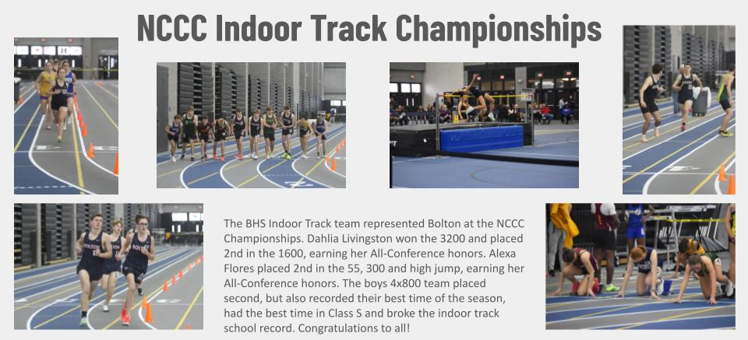
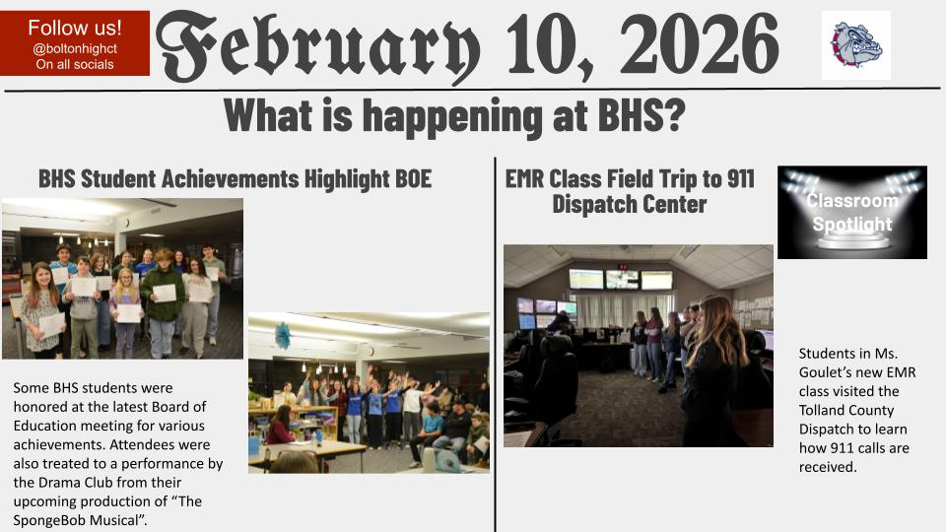

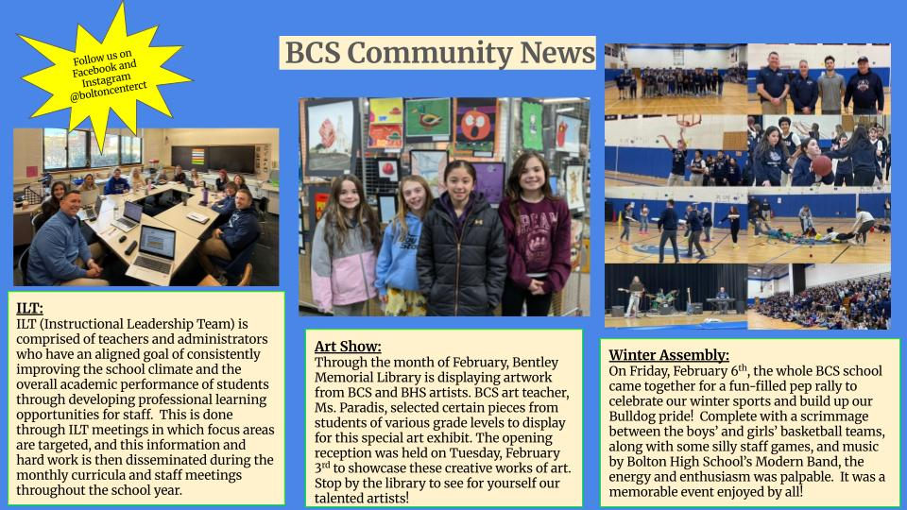

CALENDAR
February | 17 | Budget Workshop #6 – 6:00 p.m.
 | 19 | Veterans Commission – 3:00 p.m.
 | 19 | Finance Committee- 7:15 p.m.
 | 20 | Heritage Farm Commission – 9 a.m.
 | 23 | Fire Commission – 7:00 p.m.
 | 24 | Board of Selectmen with A/P – 6:00 p.m. TOWN HALL
 | 24 | Inland Wetlands Commission – 7:00 p.m.
 | 26 | BLRWPCA – Public Hearing 7:00 p.m.

