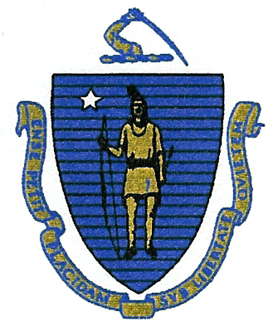
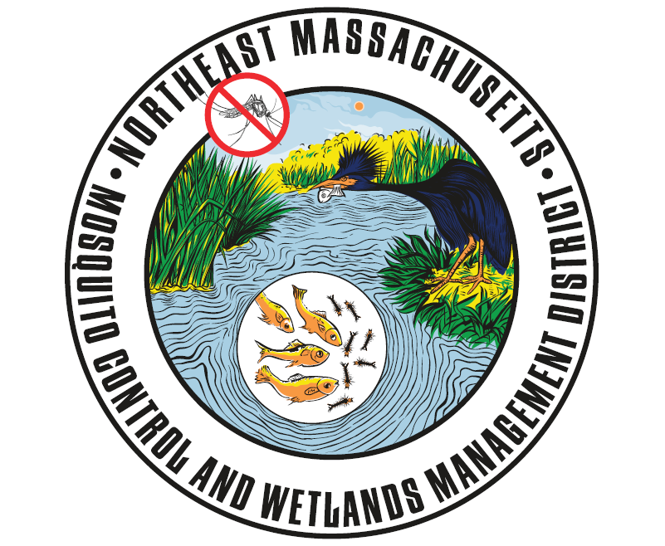
Commonwealth of Massachusetts
State Reclamation and Mosquito Control Board

Northeast Massachusetts Mosquito Control
and Wetlands Management District
118 Tenney Street
Georgetown, MA 01833
Phone: (978) 352-2800
www.nemassmosquito.org

Commissioners
Roy E. Melnick: Executive Director John W. Morris, CHO: Chair
William Mehaffey, Jr.: Operations Manager Vincent J. Russo, MD, MPH: Vice Chair
Katelynn King: Wetlands Project Technician Paul Sevigny, RS, CHO
Kimberly A. Foss.: Entomologist Joseph T. Giarrusso, Conservation Officer
Robyn A. Januszewski: Biologist Rosemary Decie, RS
DATE POSTED: April 17 2020

PUBLIC MEETING NOTICE AND AGENDA

NEMMC District Board of Commissioner’s Meeting
April 22, 2020
3:00pm
THE MEETING WILL BE BY TELEPHONE CONFERENCE
As posted with the Commonwealth of Massachusetts Office of the Secretary of State, the Executive Office of Administration and Finance, the State Reclamation and Mosquito Control Board and all subscribing communities, there will be a meeting of the Northeast Massachusetts Mosquito Control and Wetlands Management District (NEMMC) Board of Commissioners to be held on April 22, 2020 at 3:00pm via telephone conference DUE TO COVID 19 EMERGENCY PROVISIONS.

Agenda as follows:

- Call to order and Attendance.
2 The meeting will be an executive session only.
To conduct strategy sessions in preparation for negotiations with nonunion personnel in Executive Session pursuant to M.G.L. c. 30A, Section 21(a)(2) (Vote for action)
- The Commission will NOT reconvene in Open Session prior to entering into Executive Session.

Adjournment.

