Revere Human Rights Commission Circle
Oct. 3 at 5:00 pm

Orientation | • | Circle process is a core mechanism for governance in indigenous communities throughout the hemisphere. Circle is a process of community building through the creation of sustainable long-term relationships between members of the Circle. Circles have been used successfully in the community on how to deal with breaking agreements and differences of opinion where all voices are heard.  Circle process is the enactment of the principles of the Indigenous Medicine Wheel, which is an ontological map that explains the order of the universe, the world, human relationships, and humanity itself. The first layer of meaning pertains to the nature of the self, which is that we are made up of four core parts: body, mind, emotion, and spirit. A human being in good relationship with itself is in good relationship with its body, mind, emotion, and spirit. At this point, it is important not to get into deterministic arguments seeking to fully understand what each of these means. From an Indigenous point of view, everybody is different and so everybody expresses each of these elements in their unique manner. The focus is less on the definitions and more on the identification of a type of landscape of human expression from which one can appreciate each person’s unique expression of self.

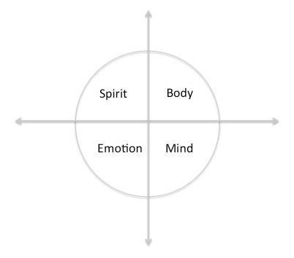
- The centerpiece: Circles use a centerpiece to create a focal point that supports speaking from the heart and listening from the heart. The centerpiece may include items representing the values of the core self, the foundational principles of the process, a shared vision of the group. Centerpieces often emphasize inclusion by incorporating symbols of individual circle members as well as cultures represented in the circle

- Talking Piece: Talking Piece is passed sunwise around the circle, no one can interrupt the person holding the talking piece, one can pass if they don't have something to share, no cross-talking, listen fully, and not interrupts, shouting at someone, judging someone, etc. Only the person holding the talking piece may speak.

Opening | There is no power greater than a community discovering what it cares about.  Ask “What’s possible?” not “What’s wrong?” Keep asking.  Notice what it cares about.  Assume that many others share your dreams.  Be brave enough to start a conversation that matters.  Talk to people you know.  Talk to people you don’t know.

Talk to people you never talk to.
Be intrigued by the differences you hear.
Expect to be surprised.
Treasure curiosity more than certainty.
Invite everybody who cares to work on what’s possible.
Acknowledge that everyone is an expert about something.
Know that creative solutions come from new connections.
Remember, you don’t fear people whose story you know.
Real listening always brings people closer together.
Trust that meaningful conversations can change the world.
Rely on human goodness.
Stay together.

—Margaret Wheatley, “Turning to One Another,” 2002

Check In | • Share one thing that you are grateful for?
Agreements | • What do you need to give yourself and what do you need from others to bring your best self here?
The Medicine  Wheel | - Reading an article about the Indigenous People’s Day  - How does this article resonate with you?  - What connection do you see between what you read and what you see today with regard to indigenous people’s rights?  - What change would you like to see moving forward?
Check Out | • What is your commitment to the change?
Closing Reading | • You must teach your children that the ground beneath their feet is the ashes of our ancestors So that they will respect the land.  Tell your children that the land is rich with the lives of our kin. Teach your children what we have taught our children - that the earth is our mother. earth does not belong to us.  We belong to the earth.  All things are connected, like the blood which unites one family.  We do not weave the web of life.  We are but a strand in the web of life.
What we do to the web, we do to ourselves.
All things are connected. — Chief Seattle

• Everything the power of the world does is done in a circle. The sky is round, and I have heard that the earth is round like a ball, and so are all the stars.
The wind, in its greatest power, whirls. Birds make their nests in circles, for theirs is the same religion as ours.
The sun comes forth and goes down again in a circle.
The moon does the same, and both are round.
Even the seasons form a great circle in their changing, and always come back again to where they were.
The life of a person is a circle from childhood to childhood, and so it is in everything where power moves.
— Black Elk

