MODEL “EX”
4” Deep Channel Frame
EXTRUDED ALUMINUM BRICK VENTS
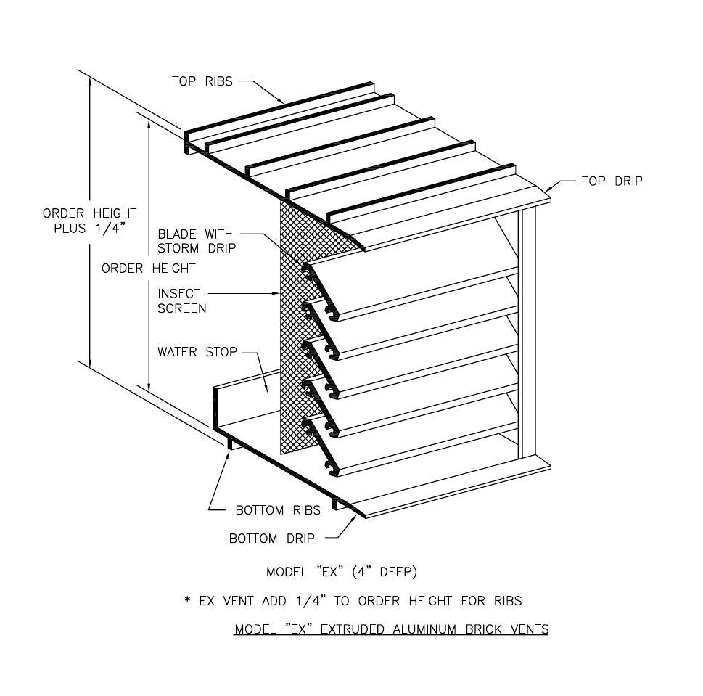

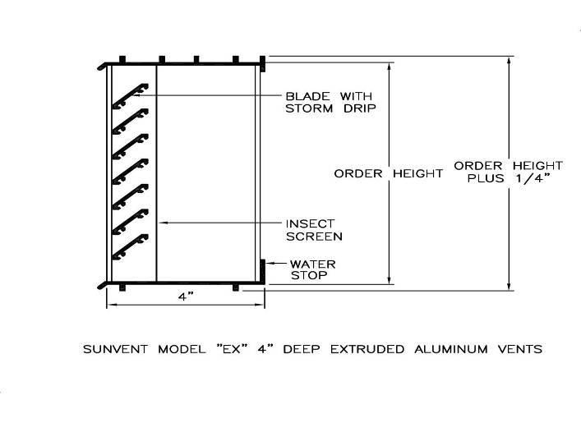
- Extruded alum. to be 6063 - T5 Alloy. Minimum .125” thick.

- Blades are 1” deep, set at 45° angles, 1” on center.

- For any unit over 30” wide - do not mortar jamb sections.

- Screens: 18 X 14 aluminum mesh

MODEL # | ORDER SIZE | FINISHED DIMENSIONS | MINIMUM OPENING REQUIRED
825 | 8-1/8”W x 2-3/8”H | 8-1/8”W x 2-5/8”H | 8-3/8”W x 2-7/8”H
847 | 8-1/8" x 4-3/4" | 8-1/8" x 5" | 8-3/8”W x 5-1/4”H
808 | 8-1/8" x 7-3/4" | 8-1/8" x 8" | 8-3/8”W x 8-1/4”H
123 | 12" x 2-3/8" | 12" x 2-5/8" | 12-1/4”W x 2-7/8”H
125 | 12" x 4-3/4" | 12" x 5" | 12-1/4”W x 5-1/4”H
128 | 12" x 7-3/4" | 12" x 8" | 12-1/4”W x 8-1/4”H
1212 | 12" x 11-3/4" | 12" x 12" | 12-1/4”W x 12-1/4”H
157 | 15-5/8" x 7-3/4" | 15-5/8" x 8" | 16”W x 8-1/4”H
1516 | 15-5/8" x 15-3/4" | 15-5/8" x 16" | 16”W x 16-1/4”H
162 | 16-1/2" x 2-3/8" | 16-1/2" x 2-5/8" | 16-3/4”W x 2-7/8”H
164 | 16-1/2" x 4-3/4" | 16-1/2" x 5" | 16-3/4”W x 5-1/4”H
168 | 16-1/2" x 7-3/4" | 16-1/2" x 8" | 16-3/4”W x 8-1/4”H
1616 | 16-1/2" x 15-3/4" | 16-1/2" x 16" | 16-3/4”W x 16-1/4”H
242 | 24" x 2-3/8" | 24" x 2-5/8" | 24-1/4”W x 2-7/8”H
244 | 24" x 4-3/4" | 24" x 5" | 24-1/4”W x 5-1/4”H
248 | 24" x 7-3/4" | 24" x 8” | 24-1/4”W x 8-1/4”H
3208 | 32" x 7-3/4" | 32" x 8" | 32-1/4”W x 8-1/4”H
4808 | 48" x 7-3/4" | 48" x 8" | 48-1/4”W x 8-1/4”H

SUNVENT INDUSTRIES  By SYLRO SALES CORP.  1 Industrial Drive, #26  Pelham NH, 03076  Toll Free: 1-800-325-4115  In NH: 603-595-4556  Fax: 603-595-4778  www.sunventindustries.com  info@sunventindustries.com | PROJECT:
 | LOCATION:
 | ARCHITECT:
 | CONTRACTOR: |  | JOB NO:
 | AGENT: |  | ORDER NO:
 | DATE:7/31/2026 | REVISIONS: | DWG NO: FL

