MODEL “EX”
with Exterior Operated Damper
EXTRUDED ALUMINUM BRICK VENTS
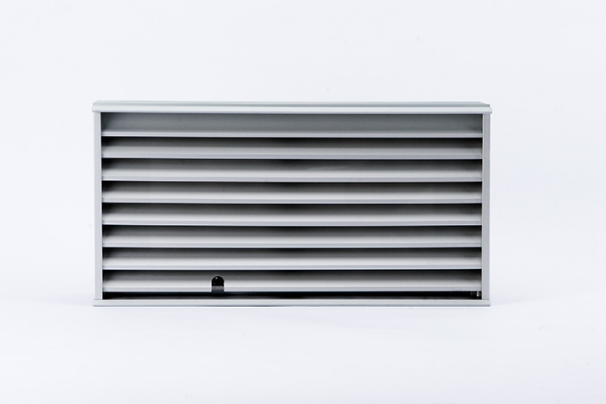
FRONT VIEW

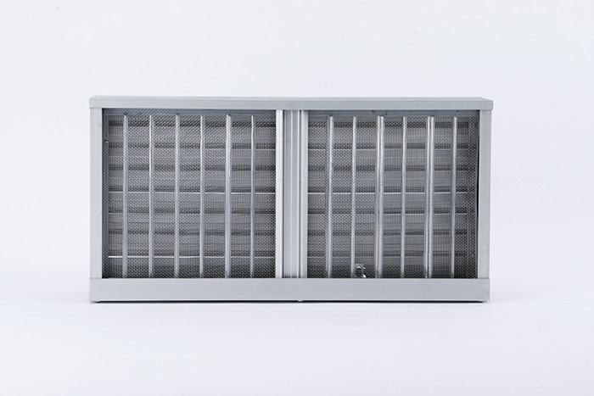
REAR VIEW

QTY | ORDER SIZE | FINISHED DIMENSIONS  (includes top and bottom ribs) | MINIMUM OPENING REQUIRED

- Extruded aluminum to be 6063 - T5 Alloy. Minimum .125” thick.
- Blades are 1” deep, set at 45° angles, 1” on center.
- For any unit over 30” wide - do not mortar jamb sections.
- Damper is manually operable from the front face with a flat head screwdriver; one operator every 20” wide. Damper is not insulated and will not keep out prolonged cold temperatures.

FINISH: |  |  |  | SCREENS: 18 X 14 aluminum mesh
SUNVENT INDUSTRIES  By SYLRO SALES CORP.  1 Industrial Drive, #26  Pelham NH, 03076  Toll Free: 1-800-325-4115  In NH: 603-595-4556  Fax: 603-595-4778  www.sunventindustries.com  info@sunventindustries.com |  | PROJECT:
 |  | LOCATION:
 |  | ARCHITECT:
 |  | CONTRACTOR: |  |  | JOB NO:
 |  | AGENT: |  |  | ORDER NO:
 |  | DATE: 7/31/2026 | REVISIONS: |  | DWG NO: EX w/OBD

