Date: [ENTER DATE]

[INSERT TOWN HEADER]

PSA Harmful Algal Blooms

WARNING: Harmful Algal Blooms (HABs) in Massachusetts Waters

Stay Safe Around Lakes, Ponds, and Rivers This Season

Warmer weather increases the risk of harmful algal blooms (HABs) in Massachusetts. These blooms can produce toxins that are dangerous to people, pets, and wildlife.

What Are Harmful Algal Blooms?

HABs are overgrowths of cyanobacteria (blue-green algae) that can appear as:
- Green paint-like scum
- Thick, pea-soup-like water
- Discolored patches or surface mats

They’re most common in late spring through early fall, especially during hot, calm weather.

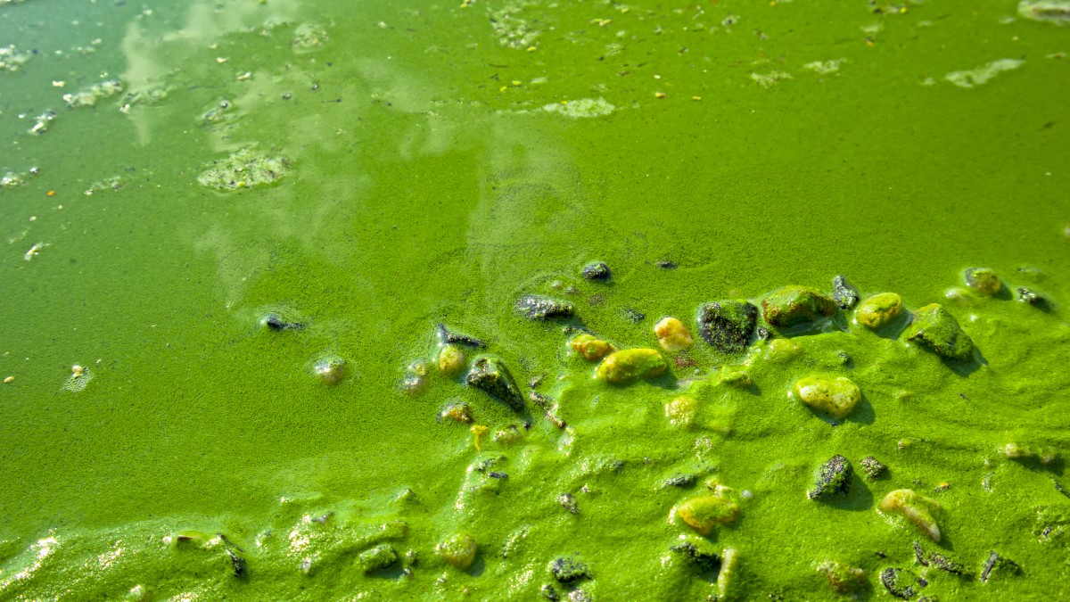
CDC: How to recognize harmful algal blooms

Why It Matters
- Touching or ingesting water with toxins can cause:
Skin or eye irritation, nausea, vomiting, diarrhea, headache, liver damage, and breathing issues.
- Pets are especially vulnerable — even ingesting small amounts of cyanobacteria can be deadly.

DO NOT:
- Swim, wade, or fish in water with visible algae.
- Let kids or pets play in or near the bloom.
- Drink untreated lake or pond water.
- Use lake water for cooking or bathing during a bloom.

DO:
- Look for posted advisory signs at lakes and ponds.
- Rinse off immediately after swimming in any natural body of water.
- Keep dogs on a leash and away from stagnant or scummy water.
- Report suspected blooms to your local health department.

Posted advisory signs may look like the image below:
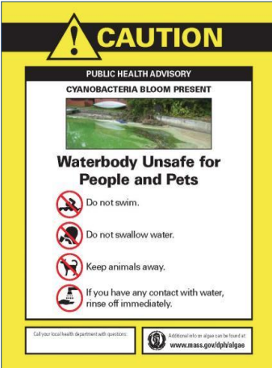

Learn More & Report Blooms

- Mass.gov Harmful Algae Blooms in Freshwater Bodies
- CDC Harmful Agal Blooms and Your Health
- EPA How People and Animals Are Exposed to HABs and Their Toxins
- EPA Harmful Agal Blooms: What You Can Do

To Report a Suspected Bloom in [ENTER NAME OF CITY OR TOWN]:
- [ENTER CONTACT or REPORTING INFORMATION]

Stay Informed. Stay Safe.
Help protect your family, pets, and the environment by spreading awareness about HABs this season.

