TRG Pittsburg NH Log Yard
10 Amey Drive – right off Route 3 in Pittsburg, NH

TIMBER RESOURCE GROUP (TRG)
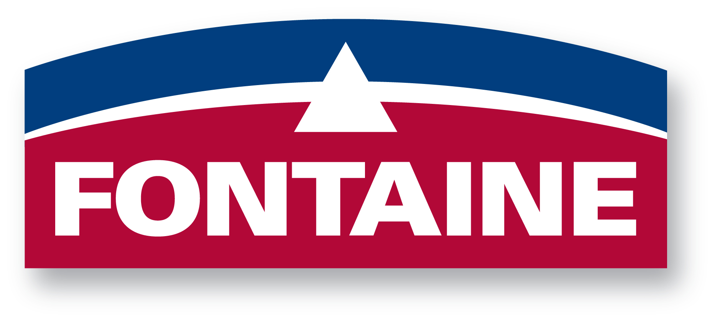
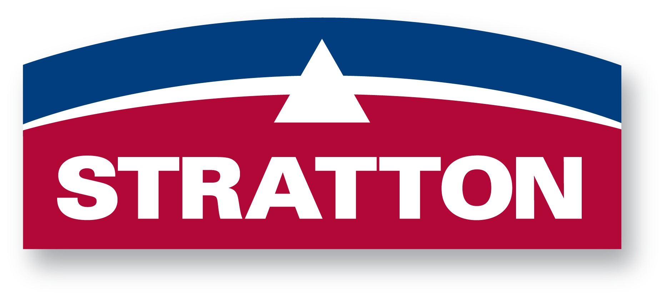
Log Buyers – John Rounds (603) 731-4032 & Craig Owen (603) 731-1903
Please contact Buyers for the latest prices, thanks.

SPRUCE AND FIR SPECIFICATIONS
Effective September 2018
Species Accepted Red, White, Black & Norway Spruce and Balsam Fir

Limbing All limbs to be cut flush with trunk.
Defects Broken stems & tops, butt shatter and splits, burned stems, forked tops, excessive crook &
sweep and dead trees are considered defects which do not meet specifications.
Pasture spruce Pasture spruce/fir not accepted. These are logs with excessive knots, burls, swells and often
excessive taper as to produce unacceptable lumber.

Stems not meeting specifications will be reloaded onto delivering truck for return to the Seller.

Spruce/Fir Sawlogs
Log Lengths 12'-14'-16' with 4" minimum trim; 6” maximum trim (especially on 16’) 16' is preferred.

Minimum Top Diameter 5” inside bark

Rot: No rot allowed
.
Scale Rule Weight Scale – wood is paid by the ton

Spruce/Fir Tree Length High Grade
Minimum Butt Diameter: 7” inside the bark Minimum Top Diameter: 4.5” inside the bark

Minimum Length: Butt logs - 16 feet 4” Whole Tree - 29 feet
Any butt logs slashed out of over-length stems must be included in the run to be weighed and
be produced into conventional log lengths of 16’ 4” only.

Butt Rot: 7” to 9” butt diameter – no rot allowed;
10”+ larger butt diameter – up to 25% solid rot accepted on up to 5 stems per load.
Scale Rule Weight scale – Wood is paid by the ton

